1) Watch terraform-05 video. 2) Execute the script shown in video.

🡪Terraform Remote state and state locking: We can store terraform configuration files and state file in github or any other repository but it is not good practise.

We use s3,terraform storage,hashicorp consul to store the state file.

State locking is used to lock the state file so that no two users can execute the state file at the same point of time.

🡪Remote backend and state locking:

We can use s3 as remote backend and dynamo db for state locking.

🡪Create s3 using terraform:

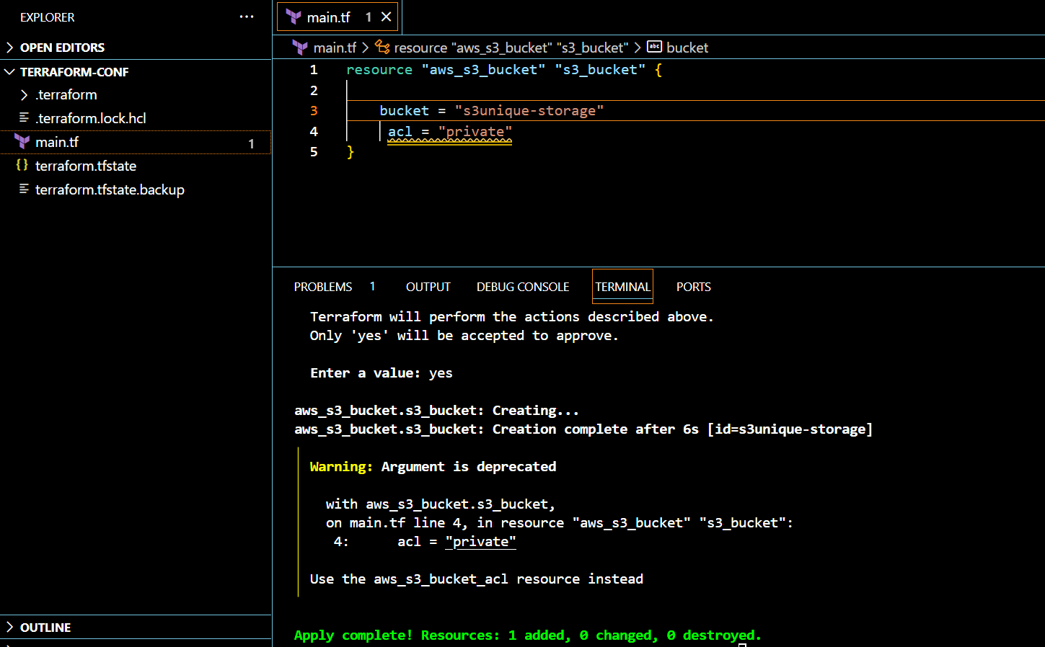

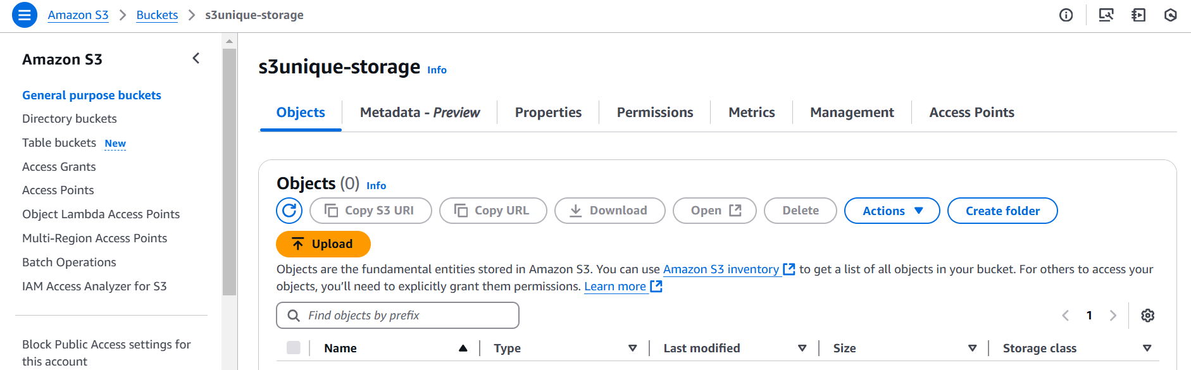

-🡪Create dynamo db using terraform for state locking:

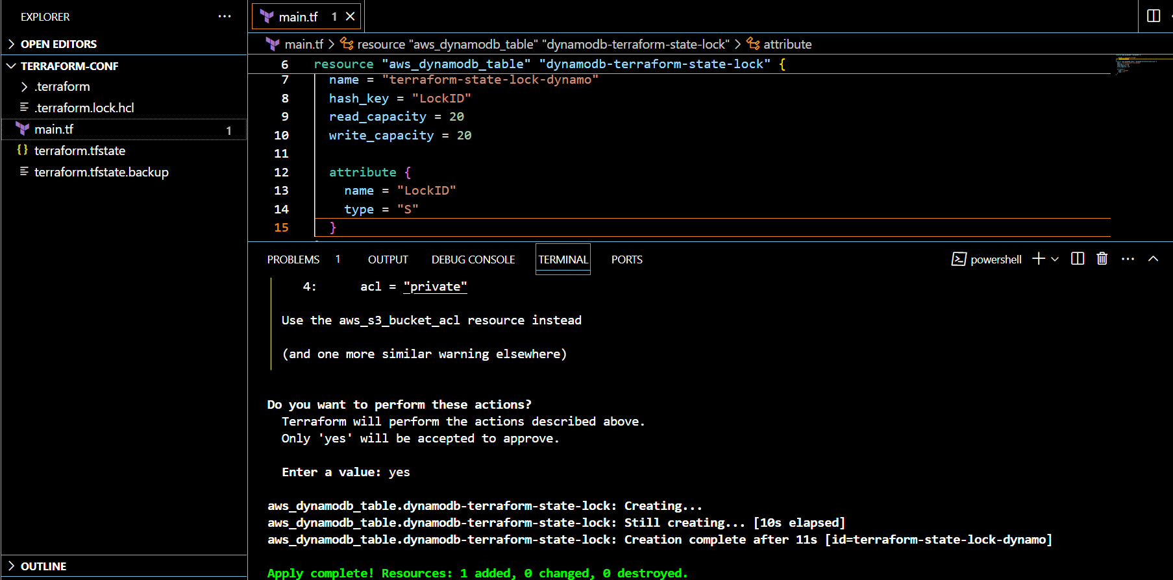

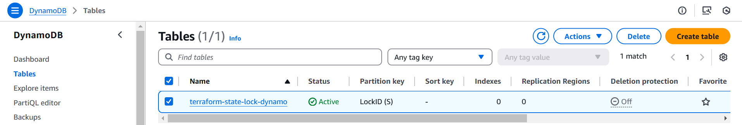

🡪after this , we need to you configure backend using terraform block. For terraform.tfstate file

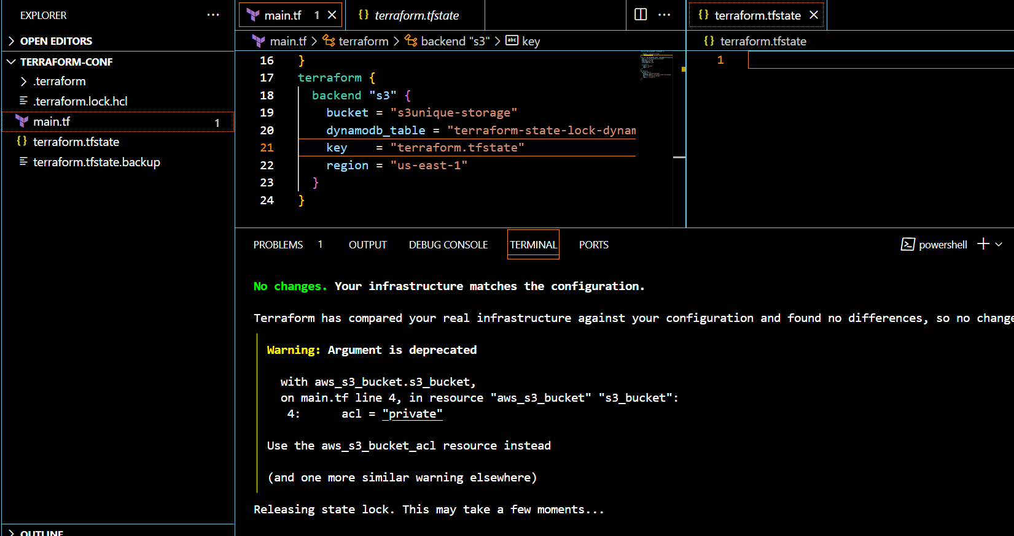

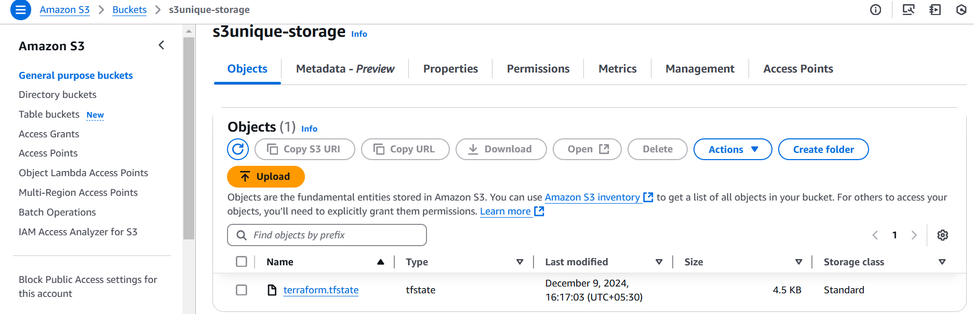

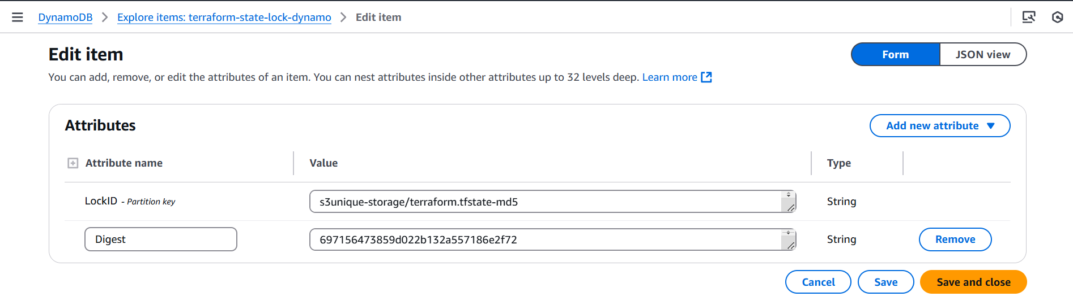

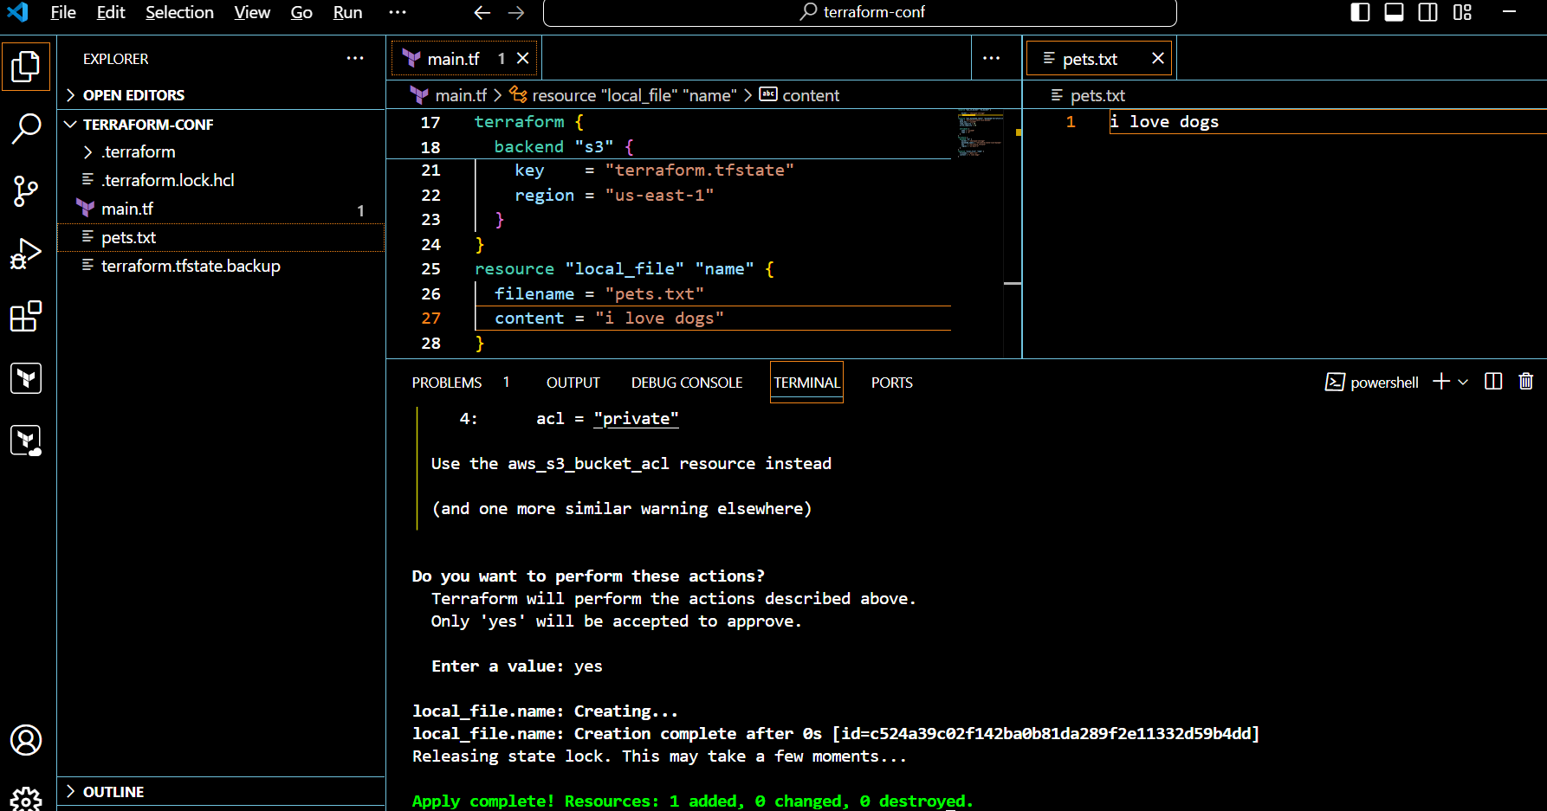

🡪Terraform Provisioners:

Terraform provisioners allow us to execute command,scripts on remote machines orlocal place were terraform is installed.Provisioners will be written inside the reource blocks.

Example:

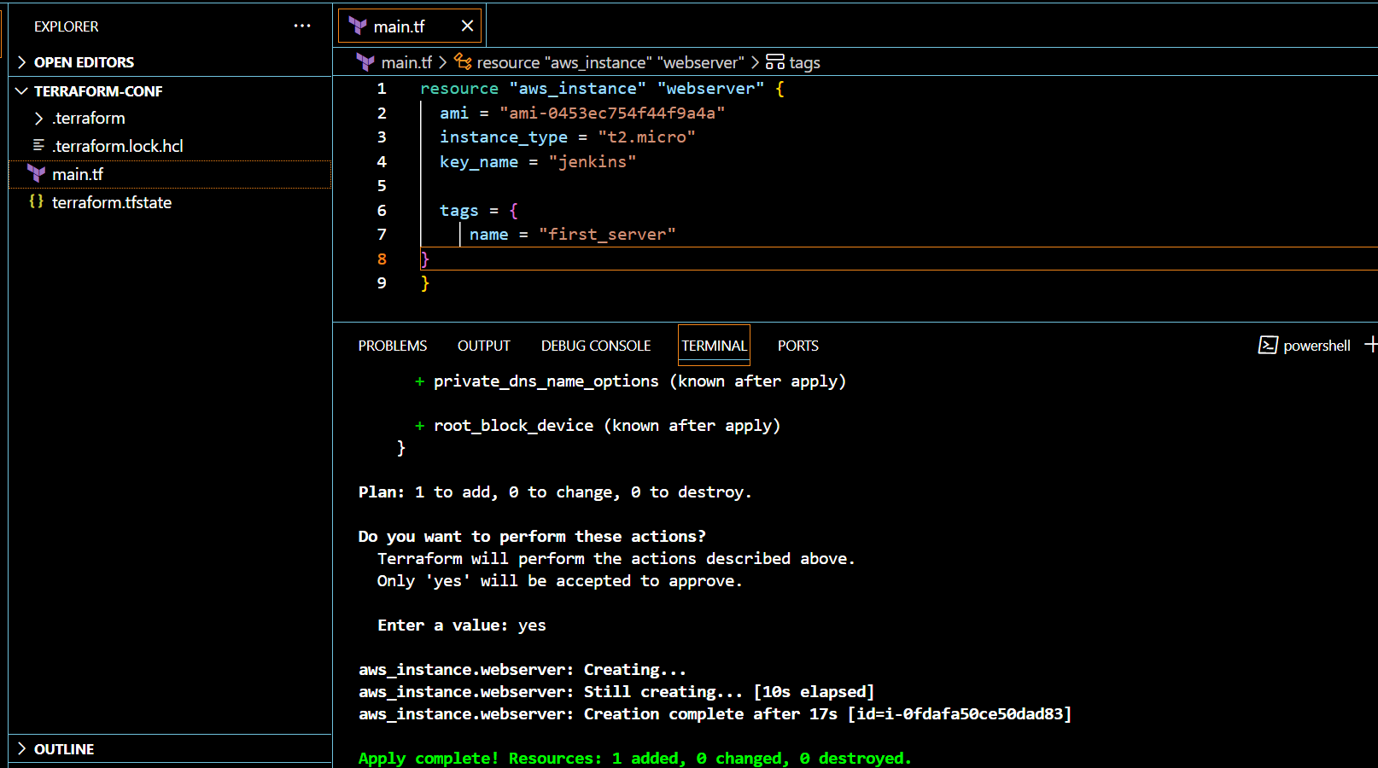

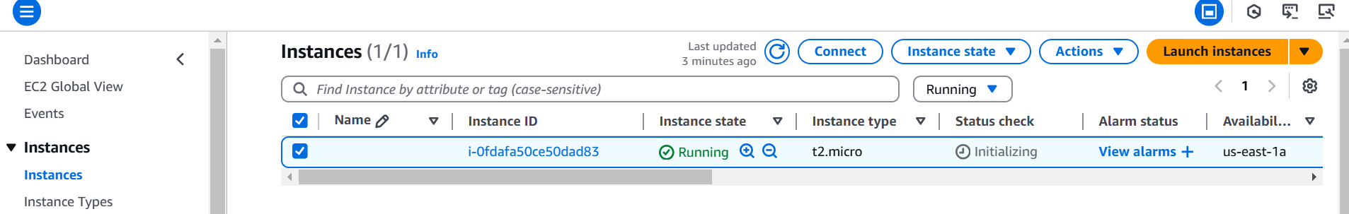

🡪We have two types of provisioners

1) Remote provisioner

This is used to execute commands at the run time on remote machines.

2) Local provisioner

This is used to execute commands at the run time on local machine.

Example of local provisioner:

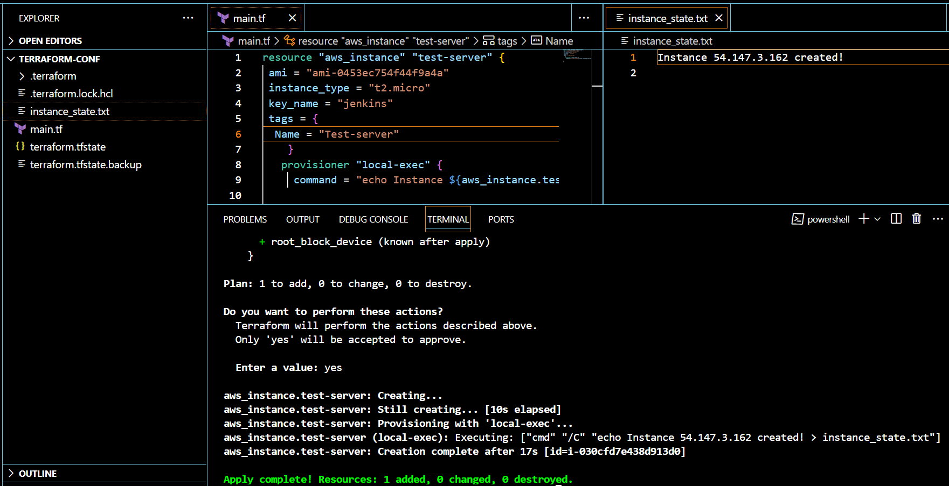

🡪We can use local provider after creating/destroying resource.

🡪After destroy we need to add when condition in provisioner.

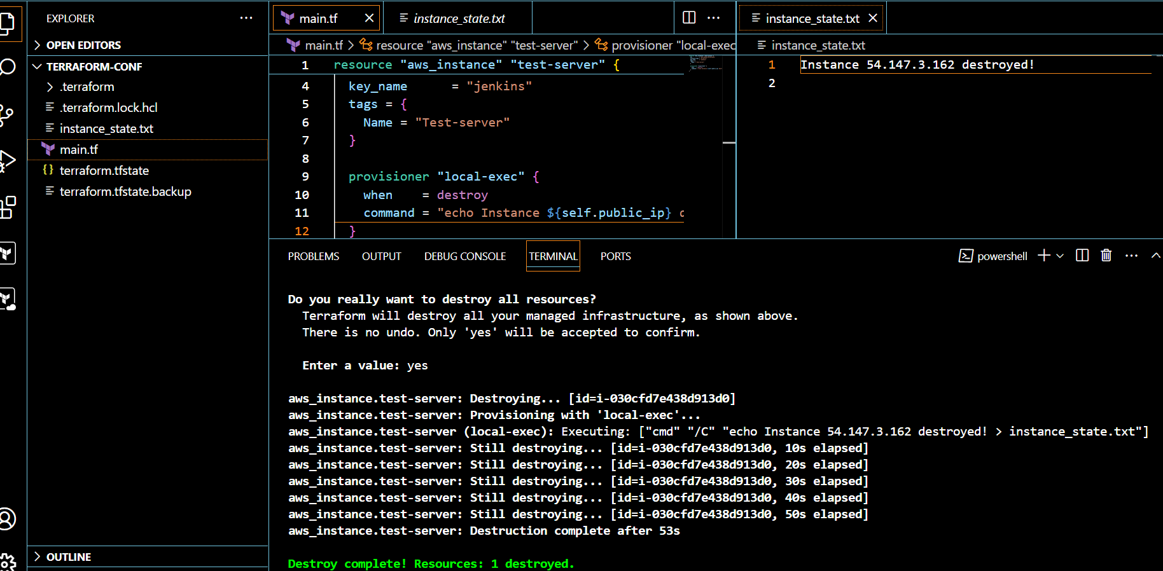

🡪Terraform taint and untaint: Thee would be cases when resource creation will get failed,if this happens

then terraform will be marked as "Tainted".

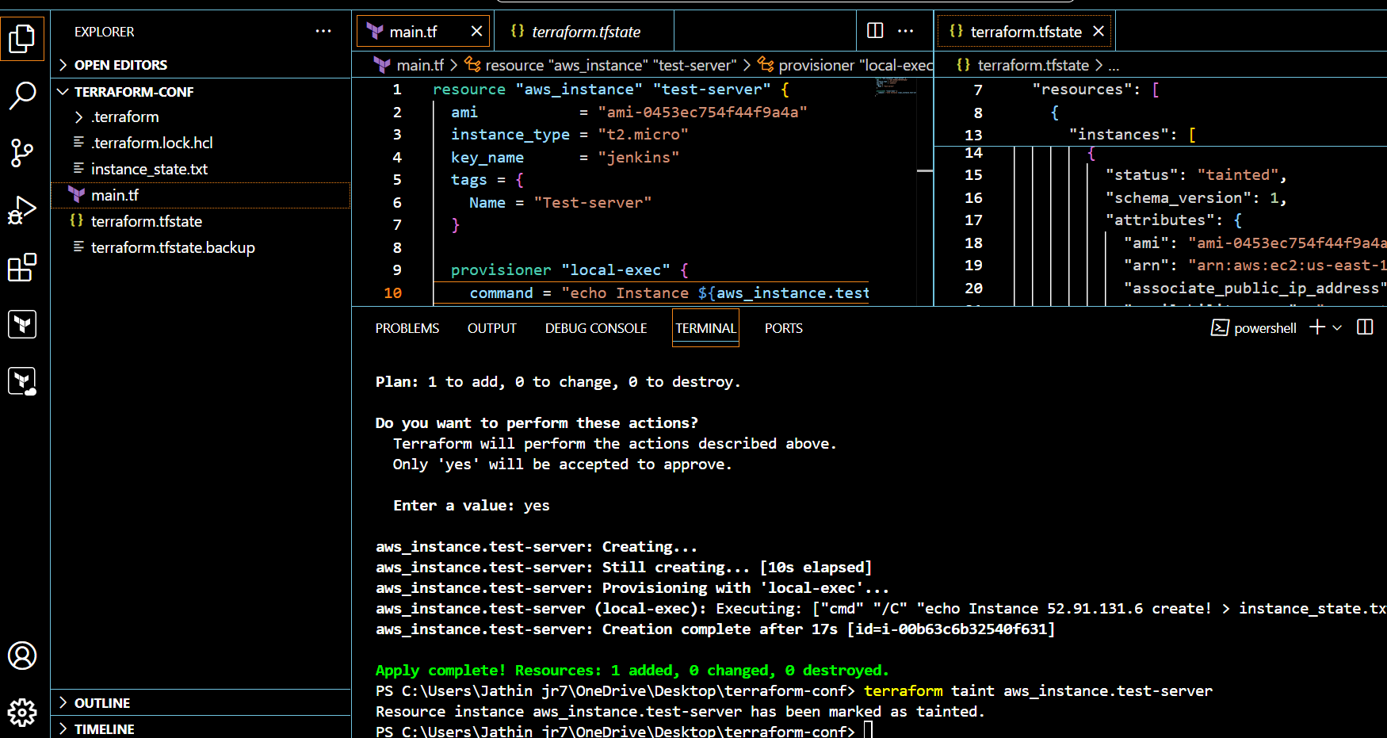

to undo the changes we can use untaint command: terraform untaint

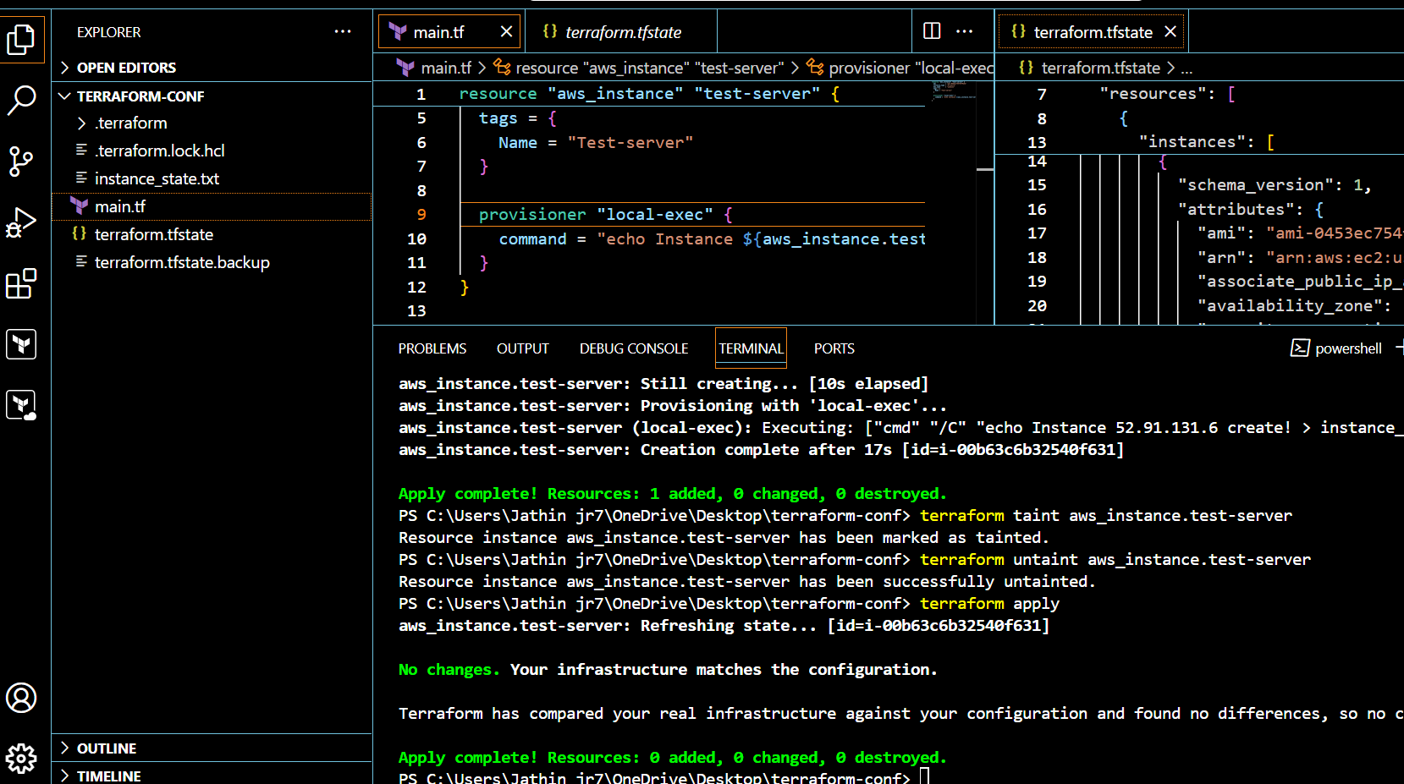

🡪Debugging: will provide us the logs

Terraform provides 5 levels of logs: Set-Item -Path env:TF_LOG -value "logsname"

1) INFO

2) WARNING

3) ERROR

4) DEBUG

5) TRACE

1)trace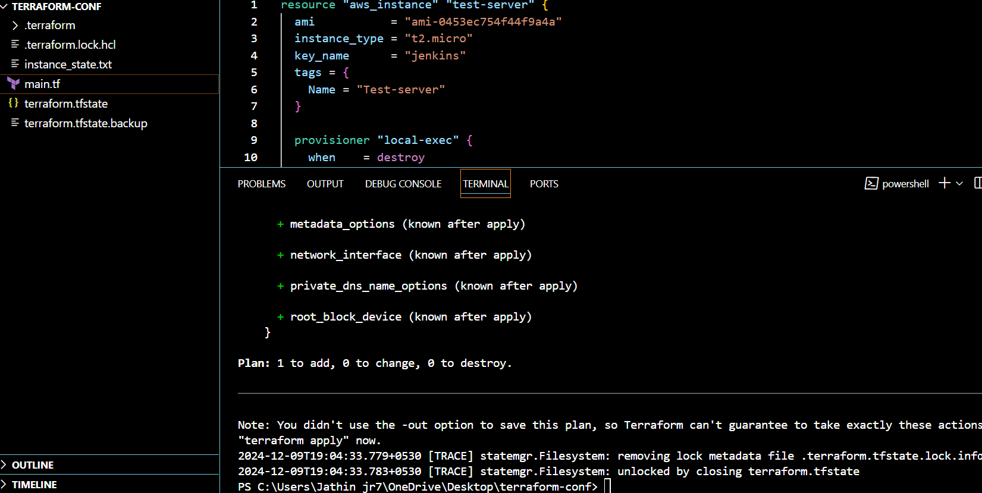

🡪To store the logs permanently then we can export a path

export TF_LOG_PATH=/tmp/terraform.log

Set-Item -Path env:TF_LOG_PATH -value "terraform.log"

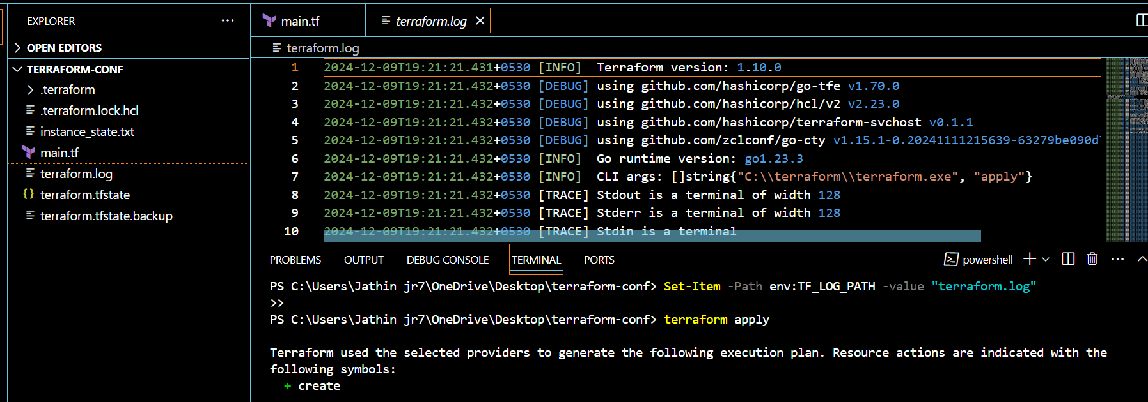

3) Create one ec2 instance with httpd installed using terraform script.

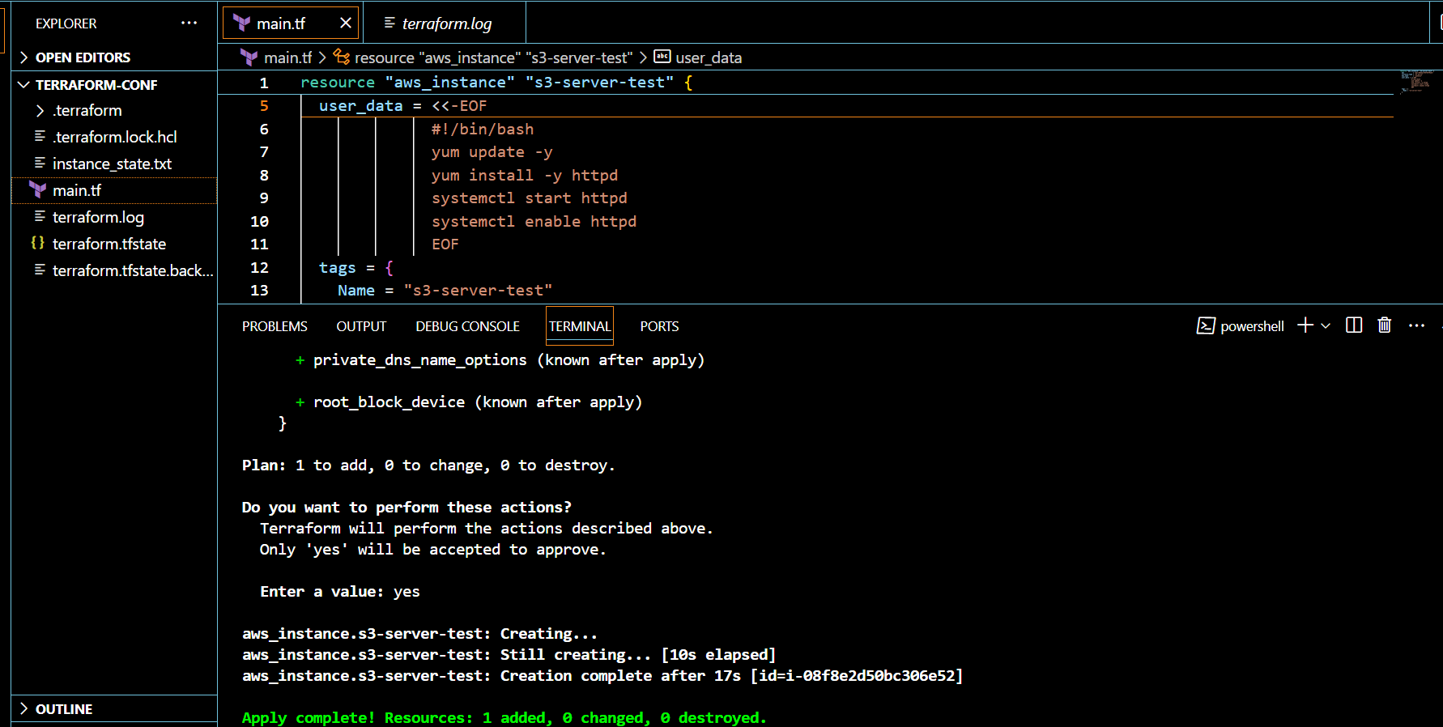

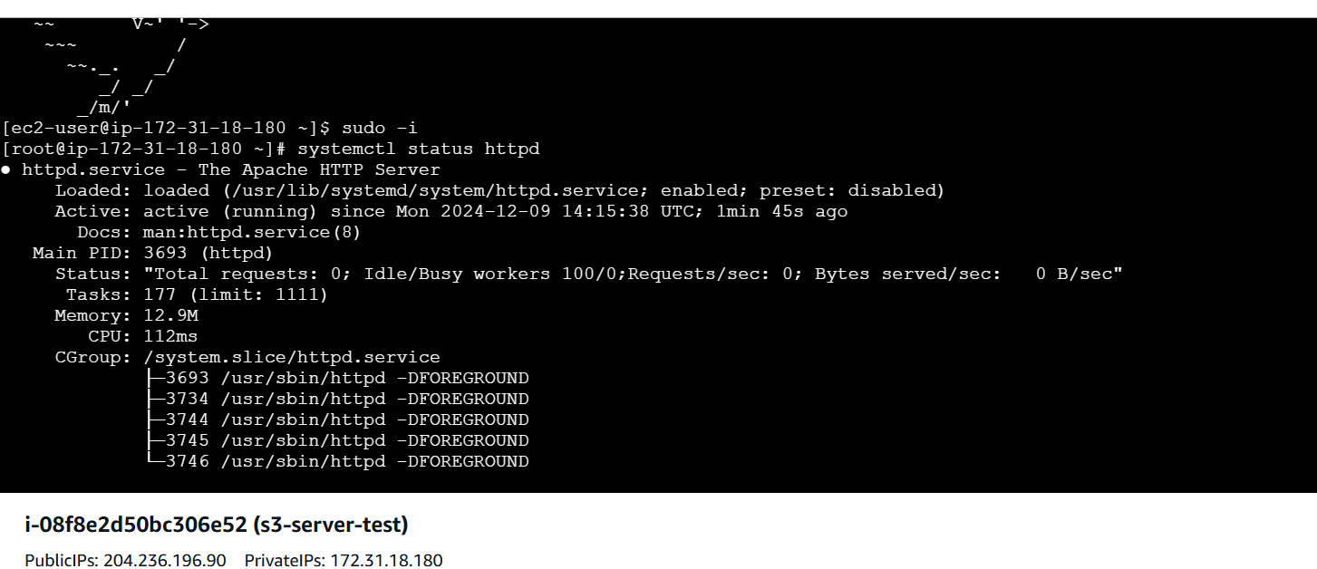

4) Setup s3 as backend to the task 3.

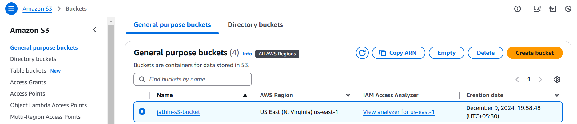

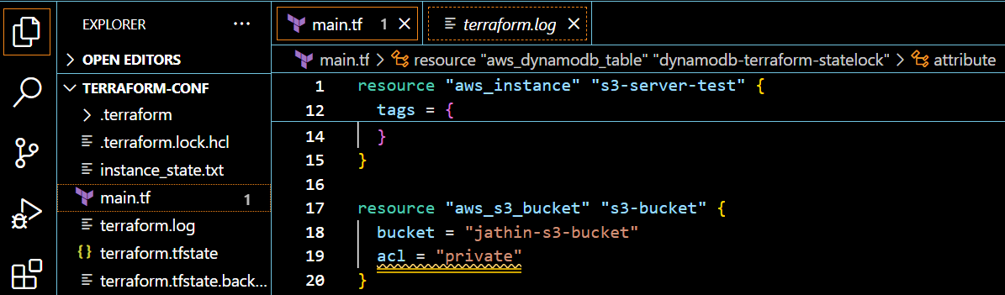

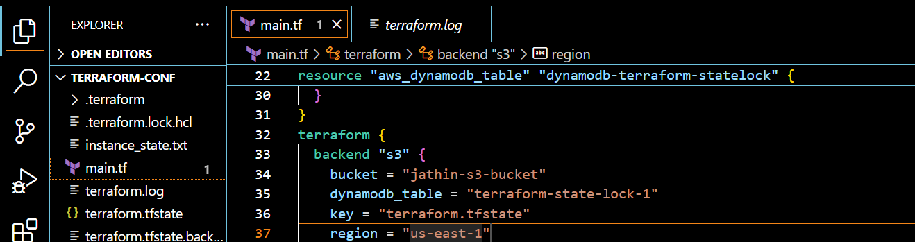

5) Setup dynamo db locking for task3.

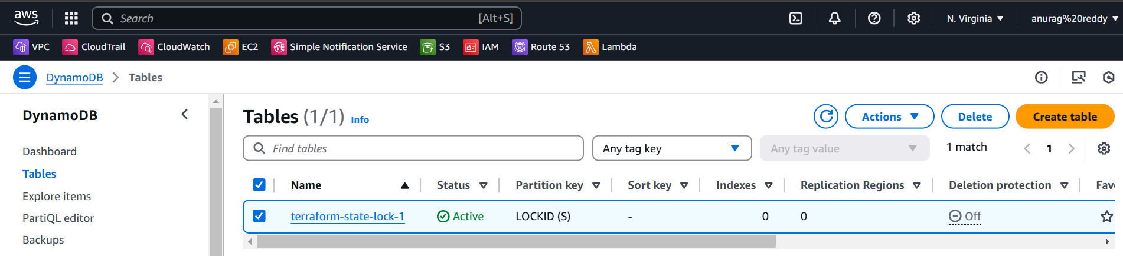

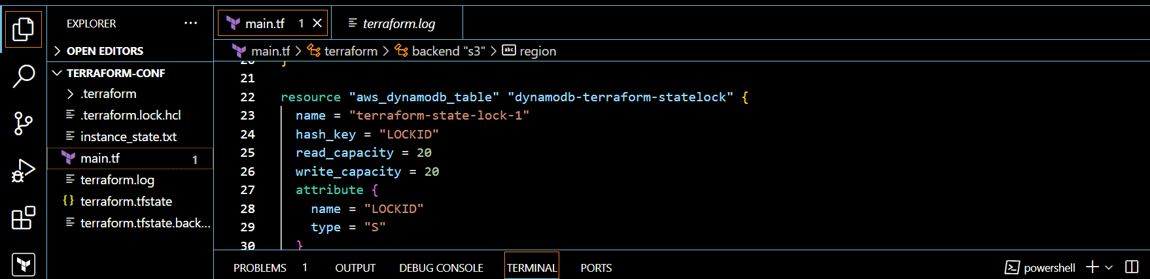

6) Watch terraform-06 video.

7) Execute the script shown in video.

8) Provision ec2, s3 and vpc using Terraform modules.

9) Provision ec2 for 3 different environments (Dev, Staging and Prod) using terraform workspaces.